OS LAB PRACTICAL 1
Basic Linux Commands
- ls , ls -a, ls -A, ls -s, ls -b, ls -h
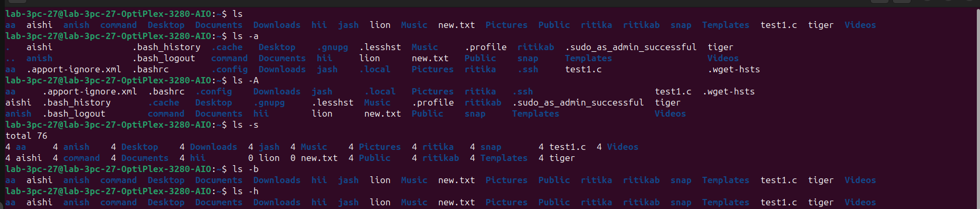

- man ls : manual command
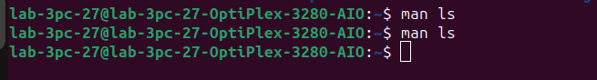
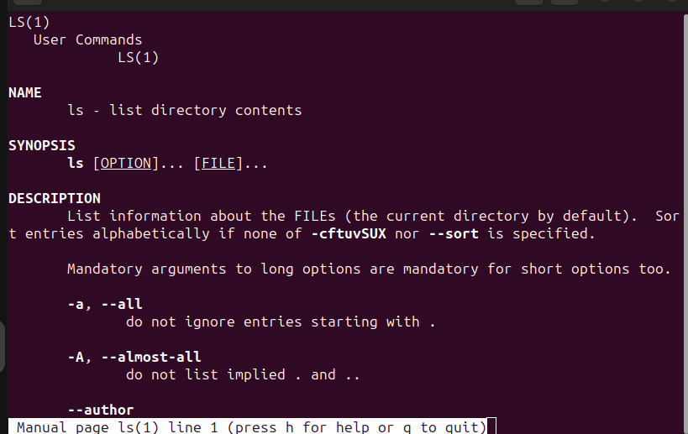

- mkdir: make directory
- rmdir: remove directory
- mv : move command
- touch command
- nano command
- cp command: copy
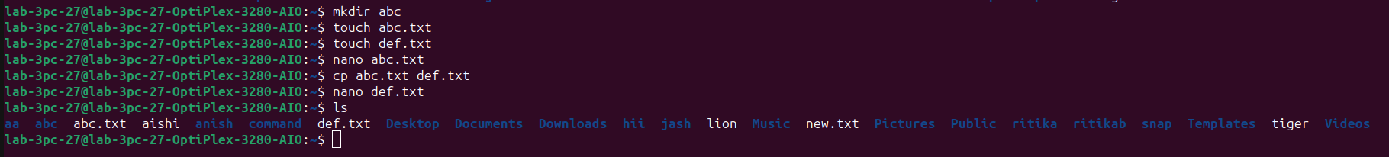

- pwd: present working directory
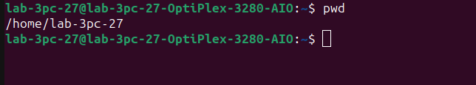

- cd command: change directory
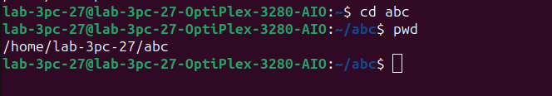
- cat command: concatenate
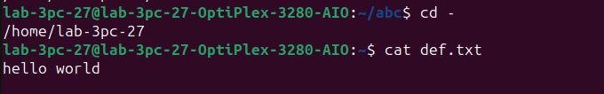
- uname command
- whoami command
- echo command
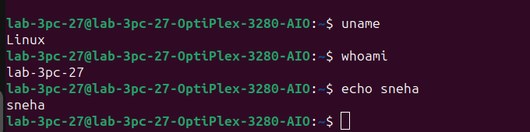
- clear command

